BACSE101 Problem Solving using Python

PROJECT REPORT
on
Project_5
Prepared by
Member 1 – AYUSH SAHU - 25BCE312
Member 2- ABHAY NIRANJA - 25BCE2574
Member 3- ARJUN VERMA - 25BCE2562
Member 4 – DIVYANSHU – 25BCE2560
Member 5 – KESHAV SINGH – 25BCEXXXX

Under the supervision of
PADMA PRIYA MAAM



School of Computer Science and Engineering
Vellore Institute of Technology, Vellore.

October 26, 2025
Table of Contents
Abstract
1. Introduction
2. Problem Statement and Objectives
3. Implementation Code
4. Demo Screenshots
5. Conclusion

Abstract

This project presents a Python-based Contact Management and Data Analysis System integrating the functionalities of Pandas and SQLite for efficient data handling and insights. The Pandas module allows data analysis operations such as filtering, grouping, and visualization of contact information, while the SQL-driven module enables structured management of contacts through an interactive, menu-based interface. The project was successfully developed and executed on Kaggle, ensuring real-time testing and analysis, and fully deployed on GitHub for collaboration and version control. This work highlights the application of Python in data management, database connectivity, and analytical processing for real-world information systems.

1. Introduction

Domain Information
The project falls under the domain of Data Management and Analysis using Python. It focuses on efficiently storing, managing, and analyzing structured data, specifically contact information. This domain combines principles of database systems, data analytics, and software development to create applications that help users organize and interpret data effectively. The project utilizes technologies like Pandas for data analysis and SQLite for database management, representing the integration of Data Science and Database Management Systems (DBMS). Such systems are widely used in industries for handling large-scale information and generating meaningful insights through analytical operations.

Software Libraries Used

Pandas: Used for data manipulation, cleaning, and analysis of contact information. It supports operations such as filtering, sorting, merging, and grouping datasets.
NumPy: Provides numerical computation and array-handling capabilities, improving the efficiency of Pandas operations.
Matplotlib: Utilized for creating visual representations like charts and graphs to make data analysis more understandable.
SQLite3: A built-in Python module used to connect and interact with the SQLite database. It allows creating, reading, updating, and deleting records through SQL queries.
- Connection Object: Establishes the link between Python and the database file.
- Cursor Object: Acts as a pointer that executes SQL commands (like SELECT, INSERT, UPDATE, DELETE) and retrieves query results.
os and sys: Used for file handling and system-level operations such as managing file paths or reading input files.

Contributions by Team Members
Member Name | Role Description
Ayush Sahu | Designed the overall code structure and implemented SQL queries for the menu-driven contact management system.
Abhay Niranjan | Developed CRUD (Create, Read, Update, Delete) operations and additional utility functions to enhance the functionality of the SQL-based module.
Arjun Verma | Integrated the contact dataset with Pandas for analytical operations using Kaggle Notebooks, and implemented visualizations using Matplotlib for data insights.
Divyanshu | Contributed to data preprocessing and analysis by implementing advanced Pandas and NumPy operations for filtering and manipulation of datasets.
Keshav Singh | Managed project testing, debugging, and coordinated the deployment of the project on GitHub and Kaggle for final presentation and demonstration.

Challenges Faced
During the development of the project, the team encountered several technical and logical challenges that required collaborative problem-solving and research. One of the primary challenges was ensuring smooth integration between the SQL-based module and the Pandas-based analysis module, as both operated on different data handling methods. Managing database connectivity and query execution using the sqlite3 library initially caused issues with cursor handling and data synchronization.
Another challenge was related to data preprocessing and cleaning in Pandas, especially when dealing with missing or inconsistent records in the contact dataset. Implementing accurate data visualization using Matplotlib also required careful selection of graph types and formatting for clarity. Additionally, maintaining code modularity and debugging errors in the menu-driven SQL program demanded structured testing and version control.
Despite these challenges, the team successfully overcame the difficulties through continuous testing, referencing documentation, and teamwork, leading to a fully functional and deployable system.

2. Problem Statement and Objectives
2.1 : PROBLEM STATEMENT :
Managing and analyzing large sets of contact information manually can be time-consuming, error-prone, and inefficient. Traditional methods such as spreadsheets or manual record-keeping lack flexibility, scalability, and analytical capabilities. There is a need for an automated system that can efficiently store, retrieve, and analyze contact details with minimal user effort. The project aims to address this problem by developing a Python-based Contact Manager and Data Analyzer that allows users to manage contacts, perform database operations, and analyze data using tools like Pandas and SQLite.

2.2 OBJECTIVES:
The main objectives of this project are:
- To develop a menu-driven contact management system using Python and SQLite for storing and retrieving contact information.
- To perform data analysis on the stored contacts using Pandas for generating insights and visualizations.
- To implement and test the project on Kaggle for data processing and on GitHub for deployment and version control.
- To demonstrate the integration of data management and data analysis in a single system.
- To create a user-friendly, reliable, and efficient tool for organizing and analyzing contact data.

3. Implementation

3.1 Feature

The project consists of two main modules — an SQL-based Contact Management System and a Pandas-based Contact Data Analysis System.
Each module provides a set of interactive and analytical features accessible through a user-friendly menu or automated execution.

3.2 Feature 1 — Add New Contact Record
Description:
This feature allows users to add a new contact’s details including name, age, gender, address, phone number, and email.
It uses SQL INSERT queries via Python’s mysql.connector to store data securely in the database.

CODE:
def create_record():
name = input("Enter Contact Name: ")
age = input("Enter your age: ")
gender = input("Enter your gender: ")
address = input("Enter Contact Residential/Official Address: ")
phone_no = input("Enter Phone Number: ")
email = input("Enter Valid Email id: ")
sql = "INSERT INTO contact_information(name,age,gender,address,phone_no,email) VALUES (%s,%s,%s,%s,%s,%s)"
record = (name, age, gender, address, phone_no, email)
cursor.execute(sql, record)
db.commit()
print("Contact Record Entered Successfully...\n")

3.3 Feature 2 — Search Contact Record
Description:
This feature enables the user to retrieve and view the details of any contact by entering their name.
It uses SQL’s SELECT query with conditional filtering.
Code:
def search(name):
sql = "SELECT * FROM contact_information WHERE name = %s"
value = (name,)
cursor.execute(sql, value)
record = cursor.fetchone()
if record is None:
print("No Such Record Exists..Try Again")
else:
print('Name:', record[0])
print('Age:', record[1])
print('Gender:', record[2])
print('Address:', record[3])
print('Phone:', record[4])
print('Email:', record[5])

3.4 Feature 3 — Display, Delete, and Modify Contacts
Description:
These features allow users to view all stored contacts, delete specific records, and modify existing data fields (like phone number or address).
Each operation uses standard SQL commands:
- SELECT → to display
- DELETE → to remove
- UPDATE → to modify records
Code :
def modify_record(name):
sql = "SELECT * FROM contact_information WHERE name = %s"
value = (name,)
cursor.execute(sql, value)
record = cursor.fetchone()
if record is None:
print("No Such Record Exists.")
else:
new_email = input("Enter New Email id: ")
sql = "UPDATE contact_information SET email = %s WHERE name = %s"
values = (new_email, name)
cursor.execute(sql, values)
db.commit()
print("Email Updated Successfully.")

3.5 Feature 4 — Data Analysis using Pandas
Description:
This module imports contact data into a Pandas DataFrame for filtering, sorting, and statistical analysis.
Operations include:
- Filtering by Age, Gender, Address, and Name Initial
- Sorting alphabetically or by age
- Computing mean, median, and standard deviation using NumPy
Code :
def filter_by_age(min_age, max_age):
result = df[(df['Age'] >= min_age) & (df['Age'] <= max_age)]
print(f"\nContacts aged between {min_age} and {max_age}:")
display(result)

3.6 Feature 5 — Data Visualization using Matplotlib
Description:
The analysis results are visualized using histograms and comparative charts to represent age distribution and gender-based trends.
This helps in better understanding the dataset through visual insights.
Code:

plt.figure(figsize=(6, 4))
plt.hist(df['Age'].dropna(), bins=10, color='skyblue', edgecolor='black')
plt.title("Age Distribution")
plt.xlabel("Age")
plt.ylabel("Count")
plt.show()

plt.figure(figsize=(6,4))
for gender in df['Gender'].dropna().unique():
subset = df[df['Gender'] == gender]['Age'].dropna()
plt.hist(subset, bins=10, alpha=0.5, label=gender)
plt.title("Age Distribution by Gender")
plt.xlabel("Age")
plt.ylabel("Count")
plt.legend()
plt.show()

4. Demo Screenshots
Paste all the relevant screenshots of your system, any important code snippet, etc here.

PANDAS:
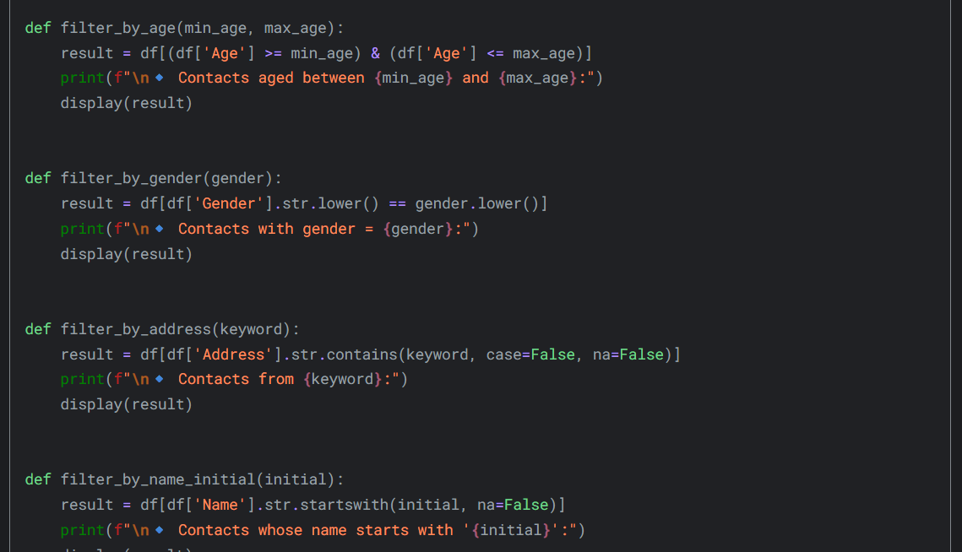

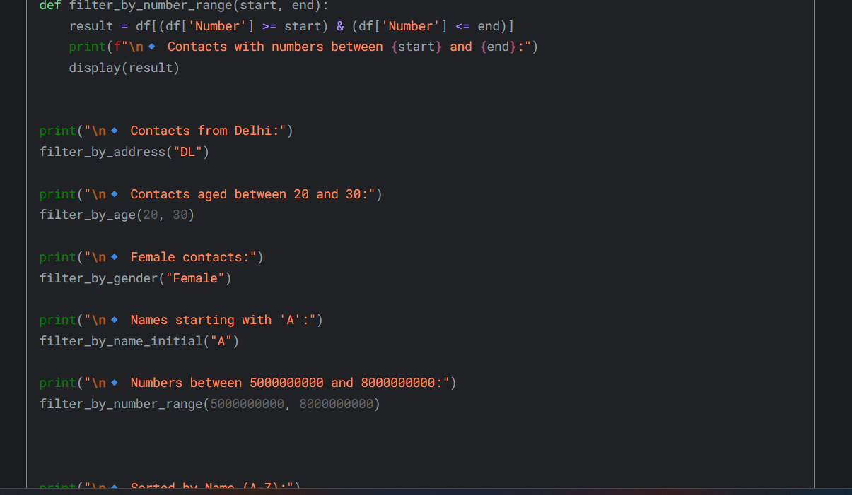

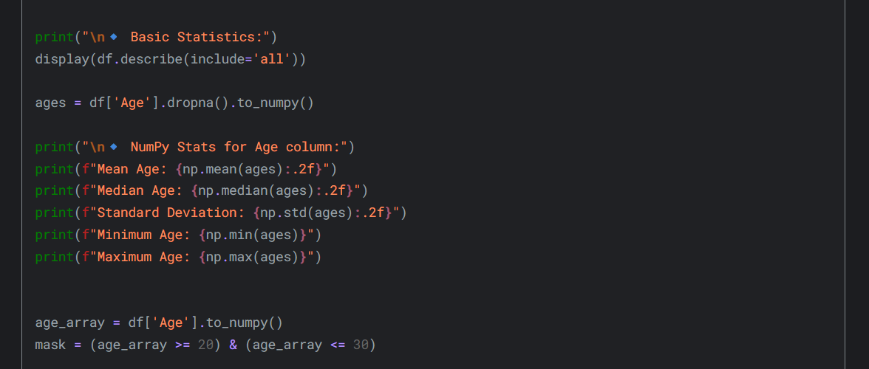

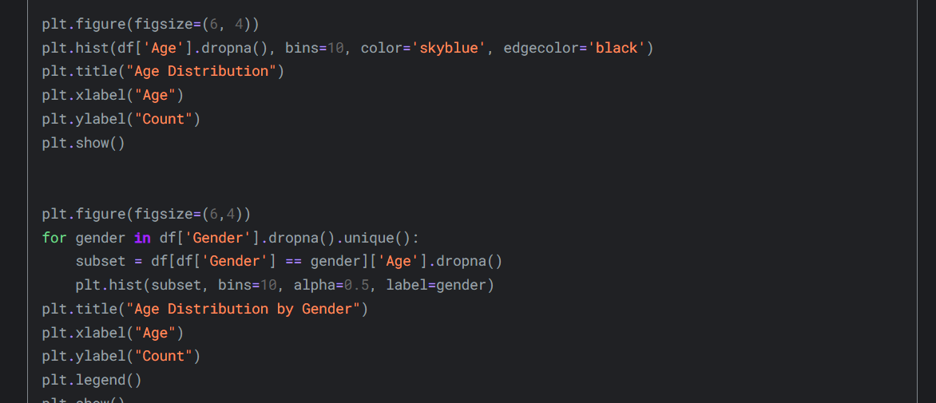

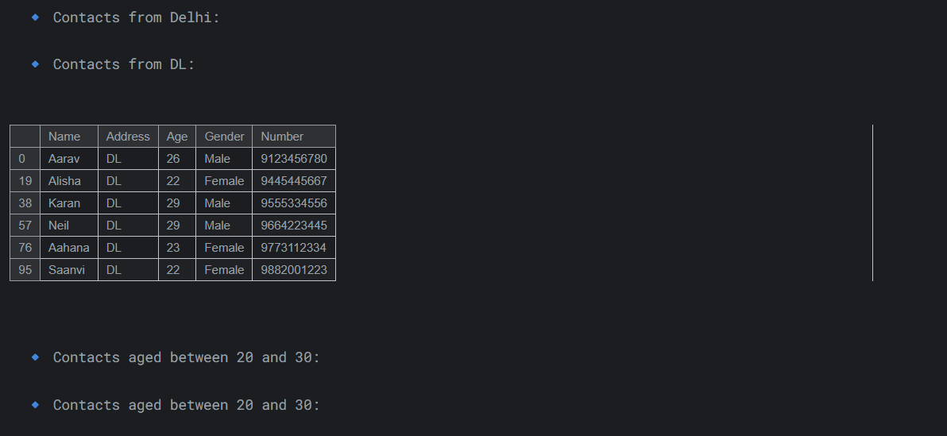

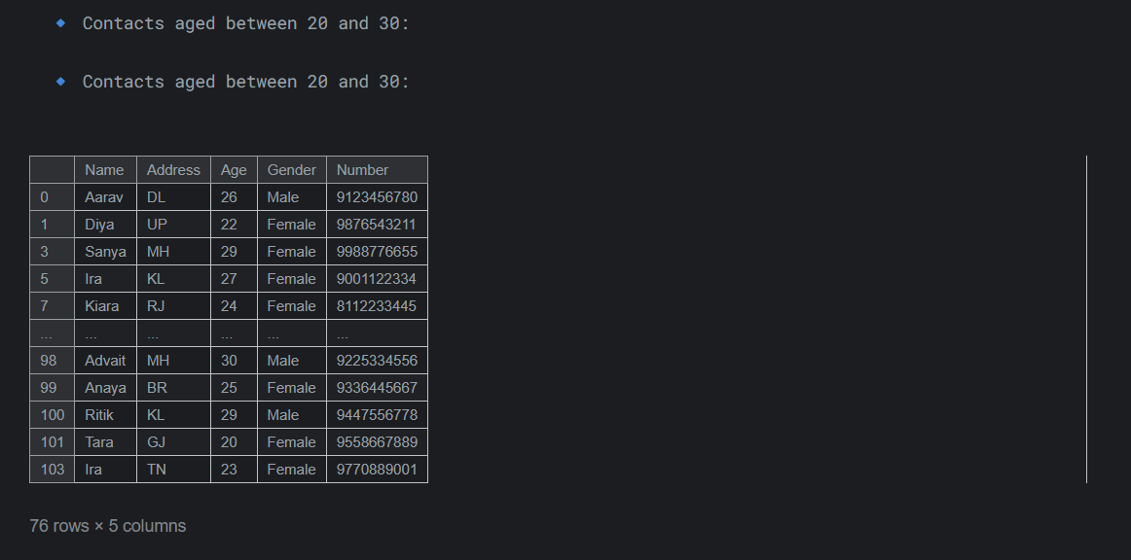

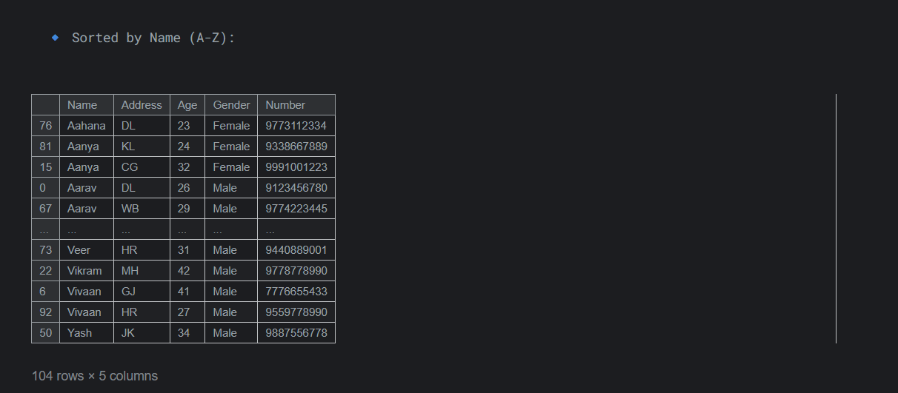

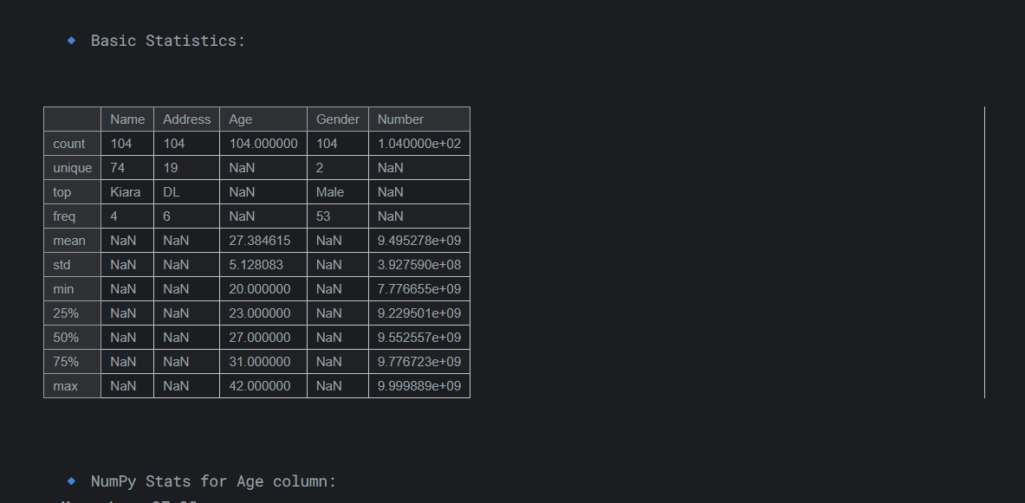

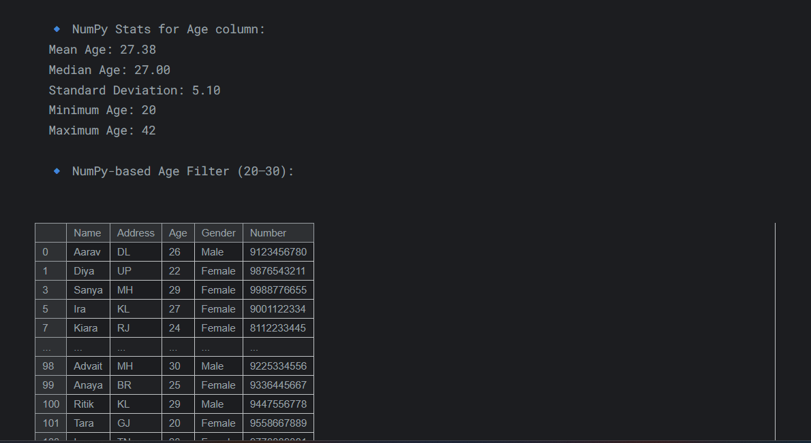

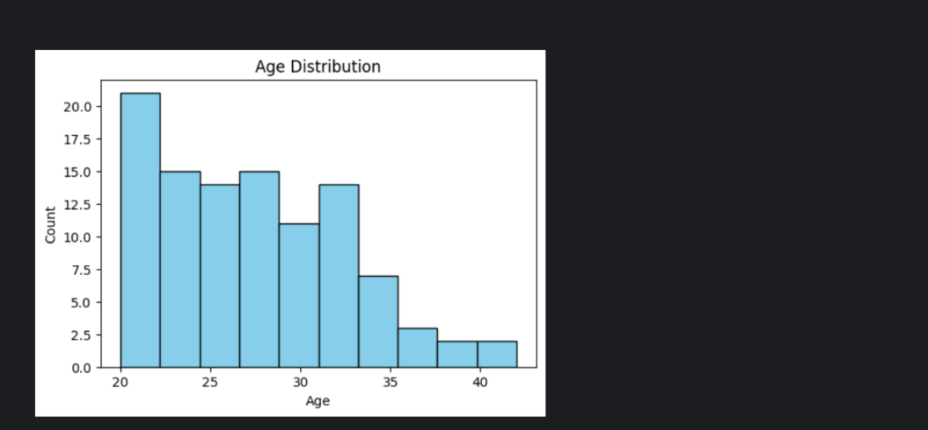

SQL :

5. Conclusion

This project successfully integrates Python, Pandas, and SQL to manage and analyze contact data efficiently. The menu-driven SQL module enables smooth CRUD operations, while Pandas provides powerful data visualization and insights. Deployment on GitHub and Kaggle ensures collaboration and accessibility, reflecting the team’s practical understanding of data handling, analysis, and real-world implementation.

